Milestone 3 — Design

Project: ULMS — University Library Management System
Course: Software Development Methods · Politehnica University of Bucharest
Author: Mihai Tintareanu
Milestone: 3 — Design

Table of Contents
3a. Design Class Diagrams 1
3a.1 Use-case → class participation map 1
3a.2 Notation conventions 1
3a.3 Per-use-case class diagrams 1
UC1 — Register Account 1
UC2 — Log In 1
UC3 — View Notifications 1
UC4 — Search Catalog 1
UC5 — Reserve Book 1
UC6 — Cancel Reservation 1
UC7 — Borrow Book 1
UC8 — Return Book 1
UC9 — Renew Loan 1
UC10 — Pay Fine 1
UC11 — Manage Catalog 1
UC12 — Manage Users 1
UC13 — Calculate Fine (system use case) 1
UC14 — Send Notification (system use case) 1
3b. Design Sequence Diagrams 1
3b.1 Notation conventions 1
3b.2 Per-use-case sequence diagrams 1
UC1 — Register Account 1
UC2 — Log In 1
UC3 — View Notifications 1
UC4 — Search Catalog 1
UC5 — Reserve Book 1
UC6 — Cancel Reservation 1
UC7 — Borrow Book 1
UC8 — Return Book 1
UC9 — Renew Loan 1
UC10 — Pay Fine 1
UC11 — Manage Catalog 1
UC12 — Manage Users 1
UC13 — Calculate Fine (system use case) 1
UC14 — Send Notification (system use case) 1
3c. Loan Statechart 1
States and triggers 1
Diagram 1
Guards 1
3d. Software Architecture 1
3d.1 Logical view 1
Package map 1
Design patterns observed 1
Cross-cutting concerns 1
3d.2 Physical view 1
Tech stack rationale 1
Configuration management 1
3e. Verification 1

3a. Design Class Diagrams
The class diagrams below refine the M2 conceptual model with the actual server-side classes implemented in src/ulms/src/main/java/dev/tmmc/ulms/. Each use case shows the controller, the service that hosts the transactional method, the repository (or repositories) it touches, and the entities involved. Cross-cutting collaborators that appear on every authenticated path — JwtAuthenticationFilter, JwtPrincipal, OwnershipChecker, GlobalExceptionHandler, SecurityConfig — are drawn once in section 3d.1 and referenced from each per-UC diagram with a note rather than redrawn 14 times.
A short clarification on two entities that look similar but are not duplicates: Book is the bibliographic + inventory record (title, author, ISBN, total/available copies, shelf number) and is the aggregate that UC4–UC11 read and write. LibraryCatalog is a small per-row metadata aggregate with only totalBooks and lastUpdated — librarians edit it through LibraryCatalogController to refresh global counters, and it does not hold book references.

3a.1 Use-case → class participation map
UC | Actor(s) | Controller | Service | Repository(ies) | Entity(ies) | External collaborators
UC1 Register Account | Student | AuthController | AuthService, UserService | UserRepository | User | PasswordEncoder, ApplicationEventPublisher, RegistrationCompletedEvent, RegistrationMailListener (@Async), MailService
UC2 Log In | Student, Librarian, Admin | AuthController | AuthService | UserRepository | User | PasswordEncoder, JwtService
UC3 View Notifications | Student | NotificationController | NotificationService | NotificationRepository | Notification, User | NotificationMapper
UC4 Search Catalog | Student, Librarian | BookController, LibraryCatalogController | BookService, LibraryCatalogService | BookRepository, LibraryCatalogRepository | Book, LibraryCatalog | BookMapper, LibraryCatalogMapper
UC5 Reserve Book | Student | ReservationController | ReservationService | ReservationRepository, BookRepository, UserRepository | Reservation, Book, User | ReservationMapper
UC6 Cancel Reservation | Student | ReservationController | ReservationService | ReservationRepository | Reservation | OwnershipChecker
UC7 Borrow Book | Student | LoanController | LoanService | LoanRepository, BookRepository, UserRepository, FineRepository | Loan, Book, User, Fine | LoanMapper
UC8 Return Book | Librarian | LoanController | LoanService | LoanRepository, BookRepository, FineRepository, ReservationRepository | Loan, Book, Fine, Reservation | LoanMapper (includes UC13)
UC9 Renew Loan | Student | LoanController | LoanService | LoanRepository, FineRepository | Loan, Fine, User | OwnershipChecker
UC10 Pay Fine | Student → Payment Gateway | PaymentController | PaymentService | PaymentRepository, FineRepository | Payment, Fine, User | PaymentGatewayClient («interface»), MockPaymentGatewayClient, PaymentMapper
UC11 Manage Catalog | Librarian | BookController, LibraryCatalogController | BookService, LibraryCatalogService | BookRepository, LibraryCatalogRepository, LoanRepository | Book, LibraryCatalog | BookMapper, BookInUseException guard
UC12 Manage Users | Administrator | UserController | UserService, LoanService, FineService | UserRepository, LoanRepository, FineRepository | User | PasswordEncoder, UserMapper, UserHistoryResponse
UC13 Calculate Fine | Scheduler | — («Component» FineCalculationJob) | FineService | LoanRepository, FineRepository | Loan, Fine, SchedulerRun | SchedulerRunRecorder
UC14 Send Notification | Scheduler | — («Component» NotificationDispatchJob) | NotificationService | LoanRepository, ReservationRepository, NotificationRepository | Loan, Reservation, Notification, SchedulerRun | SchedulerRunRecorder

3a.2 Notation conventions
- Stereotypes label the role of each class: <<RestController>>, <<Service>>, <<Repository>>, <<Entity>>, <<Mapper>>, <<Component>> (jobs), <<Filter>>, <<Strategy>>, <<interface>>.
- A ..> arrow means uses (typical controller → service → repository wiring). A solid --> with multiplicity marks a JPA association between entities. A ..|> arrow marks interface realization (used for MockPaymentGatewayClient ..|> PaymentGatewayClient).
- Operation lists are pruned to the 3–5 methods exercised by the use case; the full class signatures live in code.
- JPA relationships are labelled with role names rather than column names. Repositories show only the custom or otherwise interesting query methods; standard JpaRepository CRUD is implied.

3a.3 Per-use-case class diagrams

UC1 — Register Account
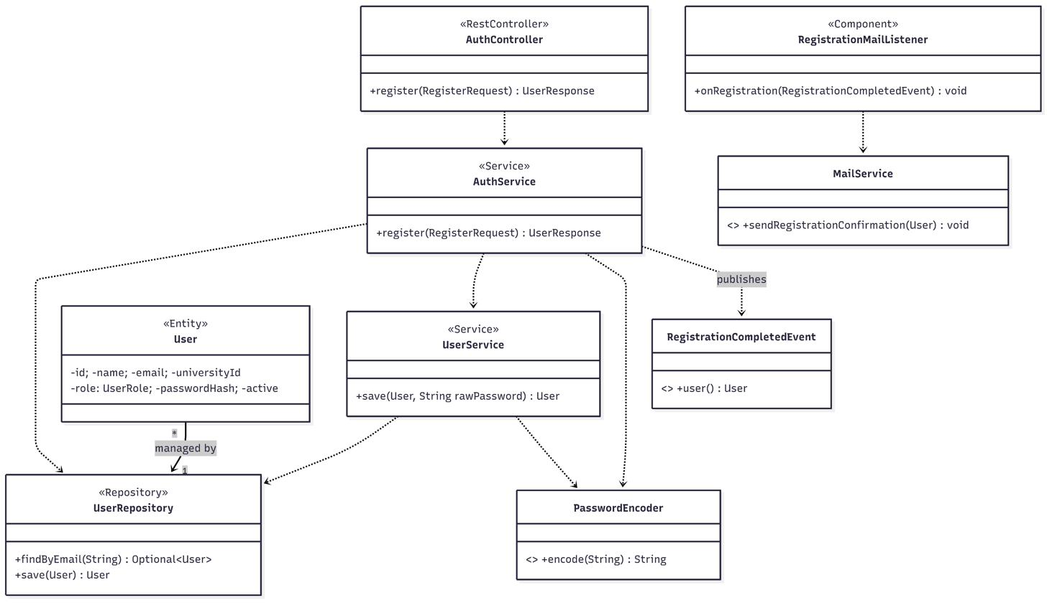
Figure 3a.1: UC1 — Register Account class diagram
Pre-authorized by JwtAuthenticationFilter is not required — /api/auth/** is permitAll. The async-email path runs after commit on the ulmsTaskExecutor thread (see 3d.1).

UC2 — Log In
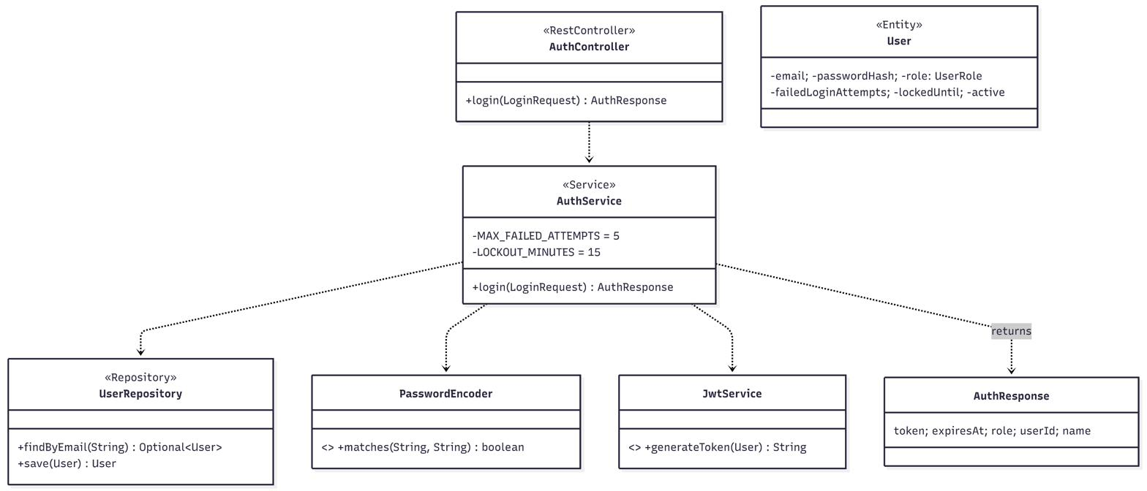
Figure 3a.2: UC2 — Log In class diagram

UC3 — View Notifications
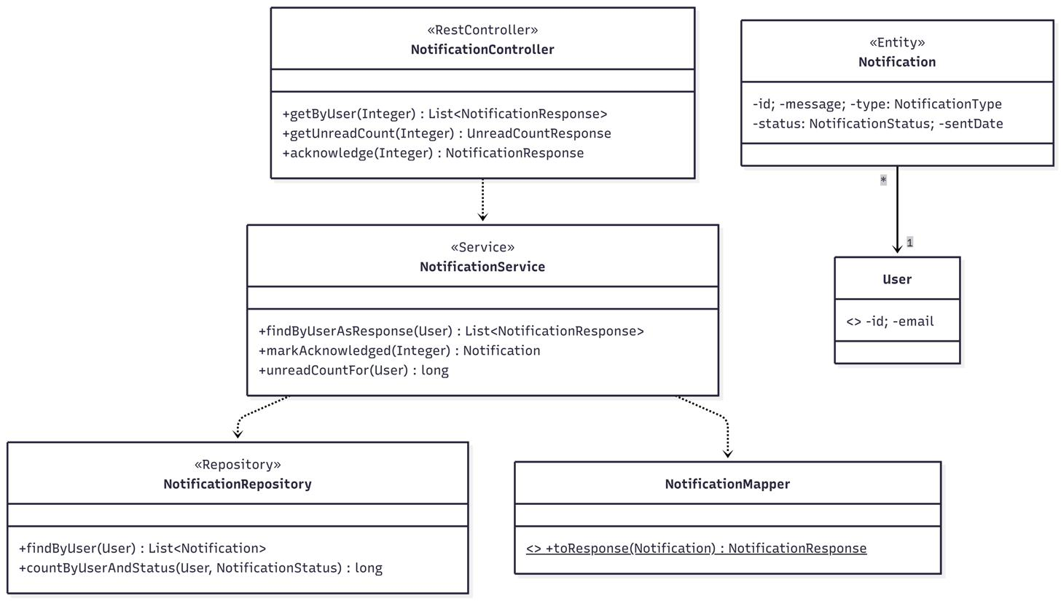
Figure 3a.3: UC3 — View Notifications class diagram
OwnershipChecker.requireOwnerOrStaff is invoked inside markAcknowledged and findByIdAsResponse (cross-cutting, see 3d.1).

UC4 — Search Catalog

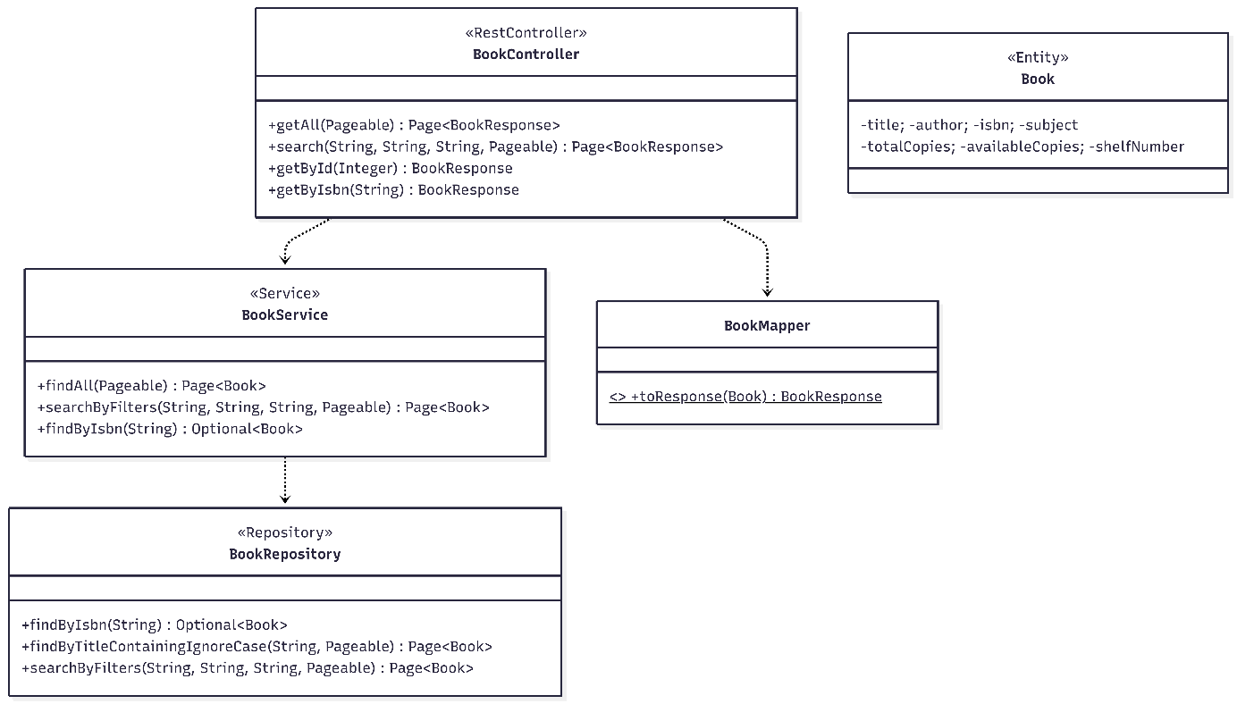
Figure 3a.4: UC4 — Search Catalog class diagram

UC5 — Reserve Book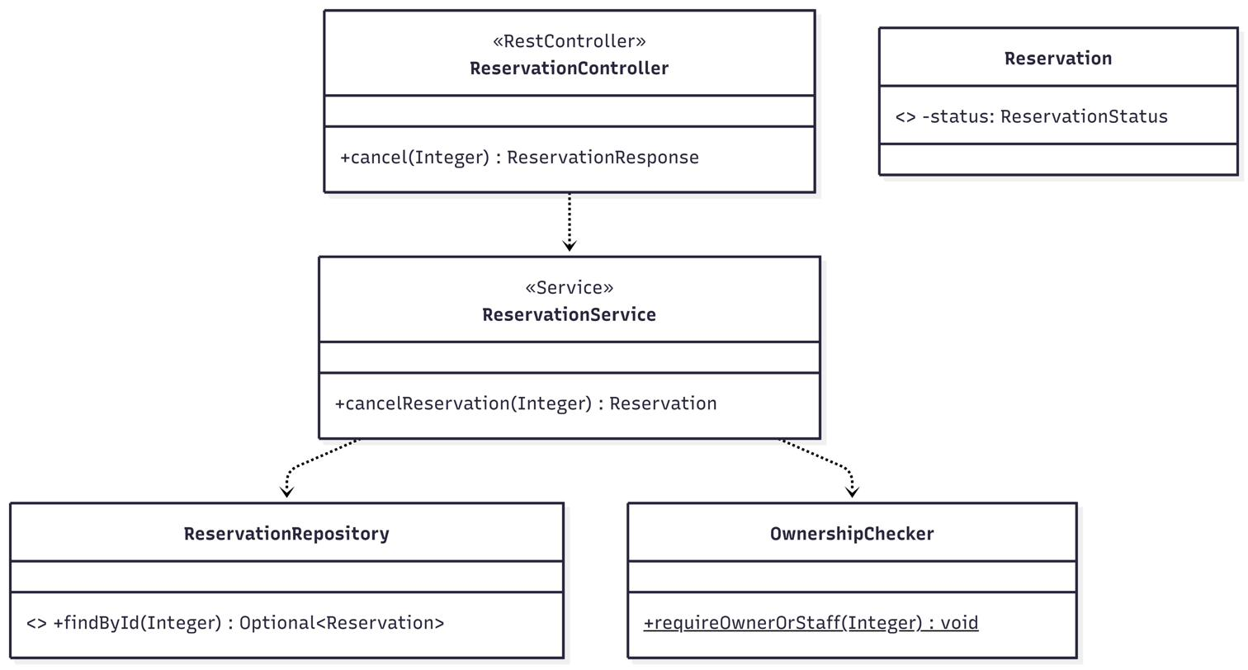
Figure 3a.5: UC5 — Reserve Book class diagram

UC6 — Cancel Reservation
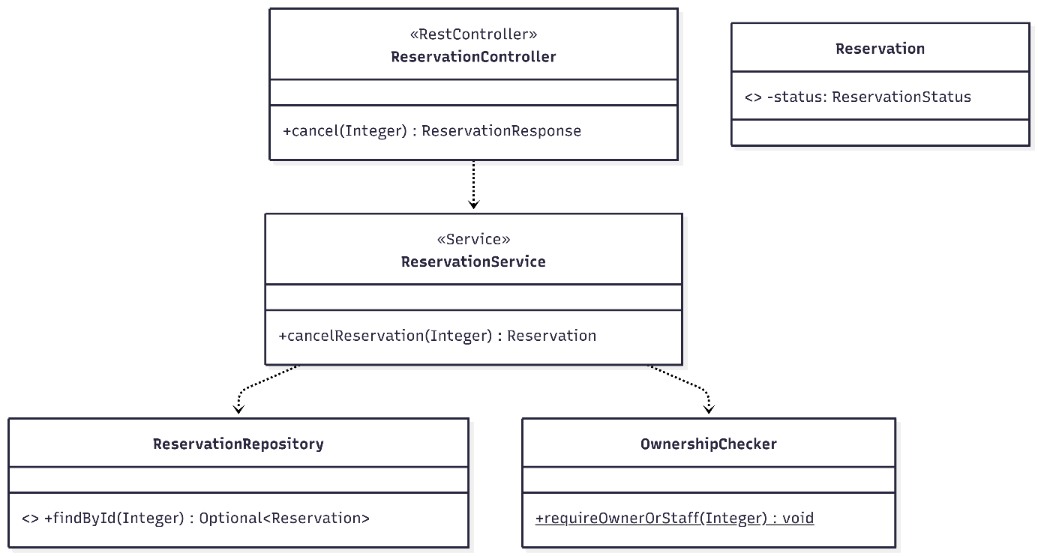
Figure 3a.6: UC6 — Cancel Reservation class diagram

UC7 — Borrow Book

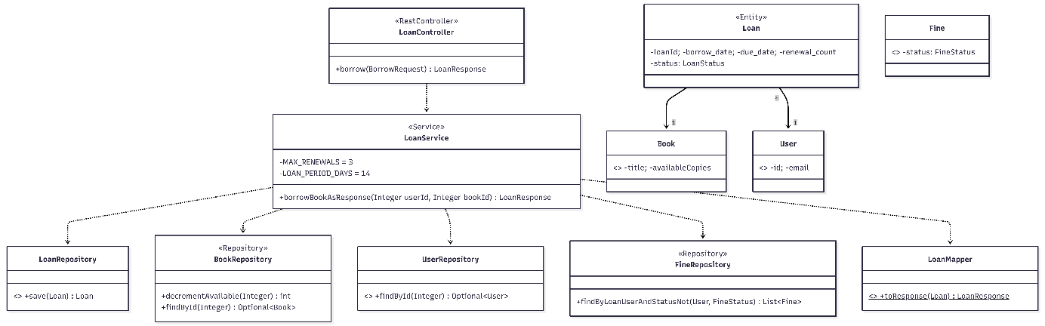
Figure 3a.7: UC7 — Borrow Book class diagram

UC8 — Return Book

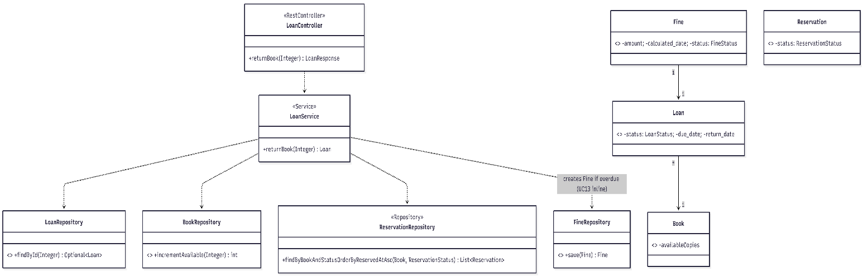
Figure 3a.8: UC8 — Return Book class diagram

UC9 — Renew Loan
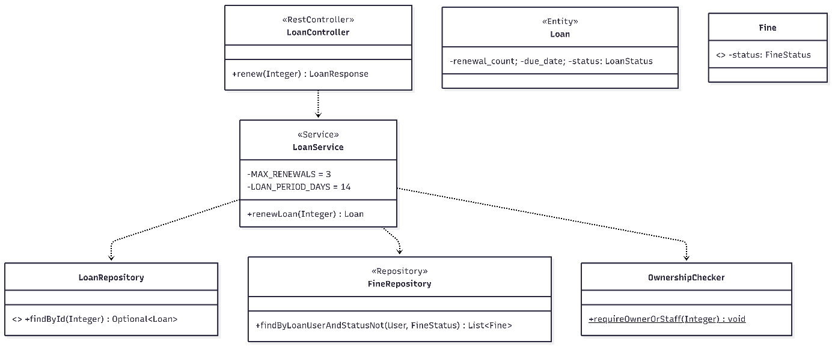
Figure 3a.9: UC9 — Renew Loan class diagram

UC10 — Pay Fine

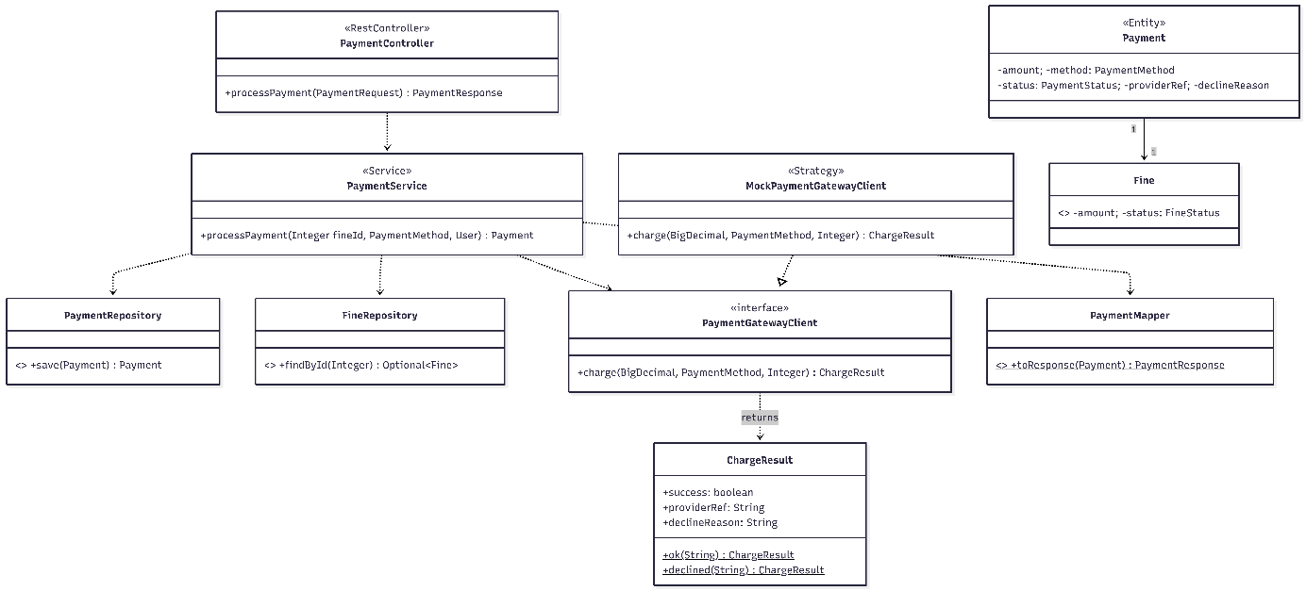
Figure 3a.10: UC10 — Pay Fine class diagram

UC11 — Manage Catalog

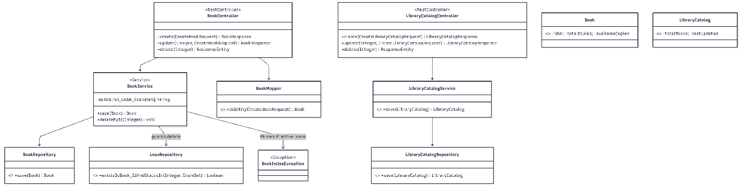
Figure 3a.11: UC11 — Manage Catalog class diagram

UC12 — Manage Users

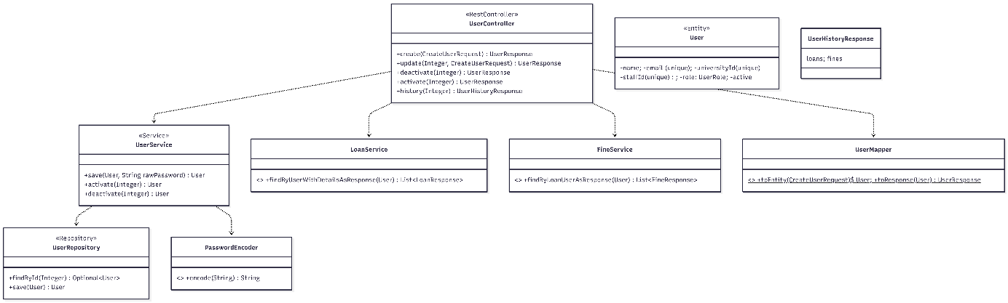
Figure 3a.12: UC12 — Manage Users class diagram

UC13 — Calculate Fine (system use case)

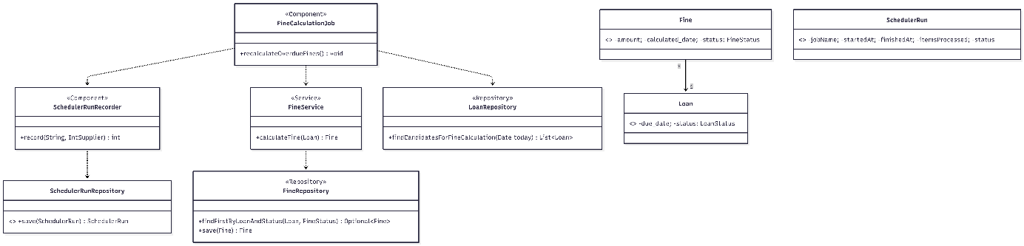
Figure 3a.13: UC13 — Calculate Fine (system use case) class diagram
No controller — FineCalculationJob is triggered by @Scheduled(cron = "0 0 2 * * *", zone = "Europe/Bucharest").

UC14 — Send Notification (system use case)
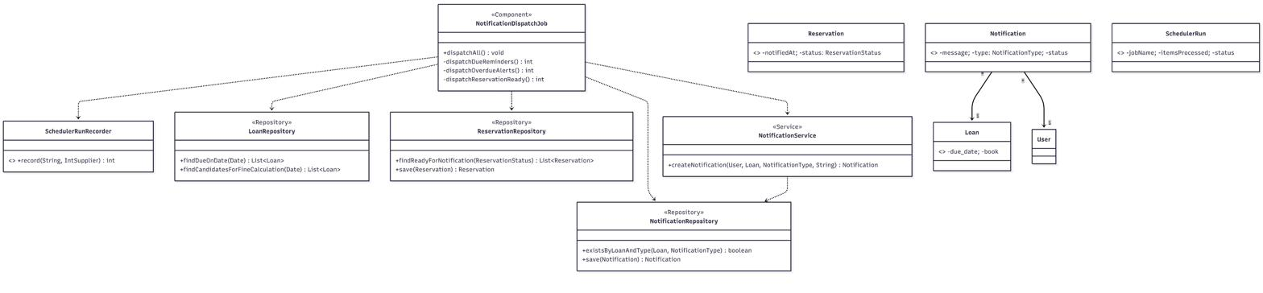
Figure 3a.14: UC14 — Send Notification (system use case) class diagram
Triggered by @Scheduled(cron = "0 5 2 * * *", zone = "Europe/Bucharest"). The three private dispatchers (dispatchDueReminders, dispatchOverdueAlerts, dispatchReservationReady) all funnel into NotificationService.createNotification and persist via NotificationRepository.

3b. Design Sequence Diagrams

3b.1 Notation conventions
- Lifelines run left-to-right in this order: actor → controller → service → repository (one or more) → entity / external collaborator. The controller is always present even when the message is short, because it is the place where Spring applies @PreAuthorize and request validation (@Valid).
- A solid arrow ->> is a synchronous call; a dashed arrow -->> is a return.
- The transactional boundary is annotated as "Note over XService: @Transactional" so that the diagrams make explicit when atomic write paths begin.
- alt frames are used only on UC2 (login: success / invalid credentials / locked account) and UC10 (payment: gateway accepted vs declined). Every other UC shows the happy path; alternate flows are documented in M2.
- For the two scheduler-driven use cases (UC13, UC14) the actor is replaced by a "participant Scheduler" and a "%% triggered by @Scheduled" comment, since there is no human in the loop.

3b.2 Per-use-case sequence diagrams

UC1 — Register Account
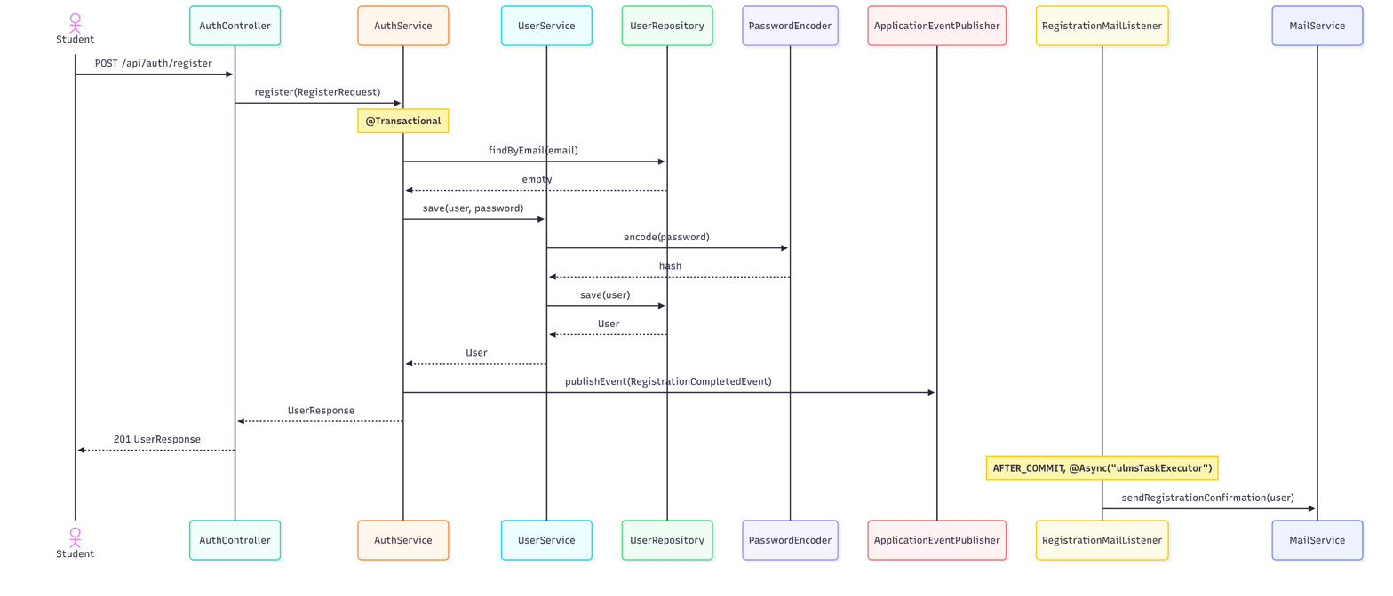
Figure 3b.1: UC1 — Register Account sequence diagram

UC2 — Log In
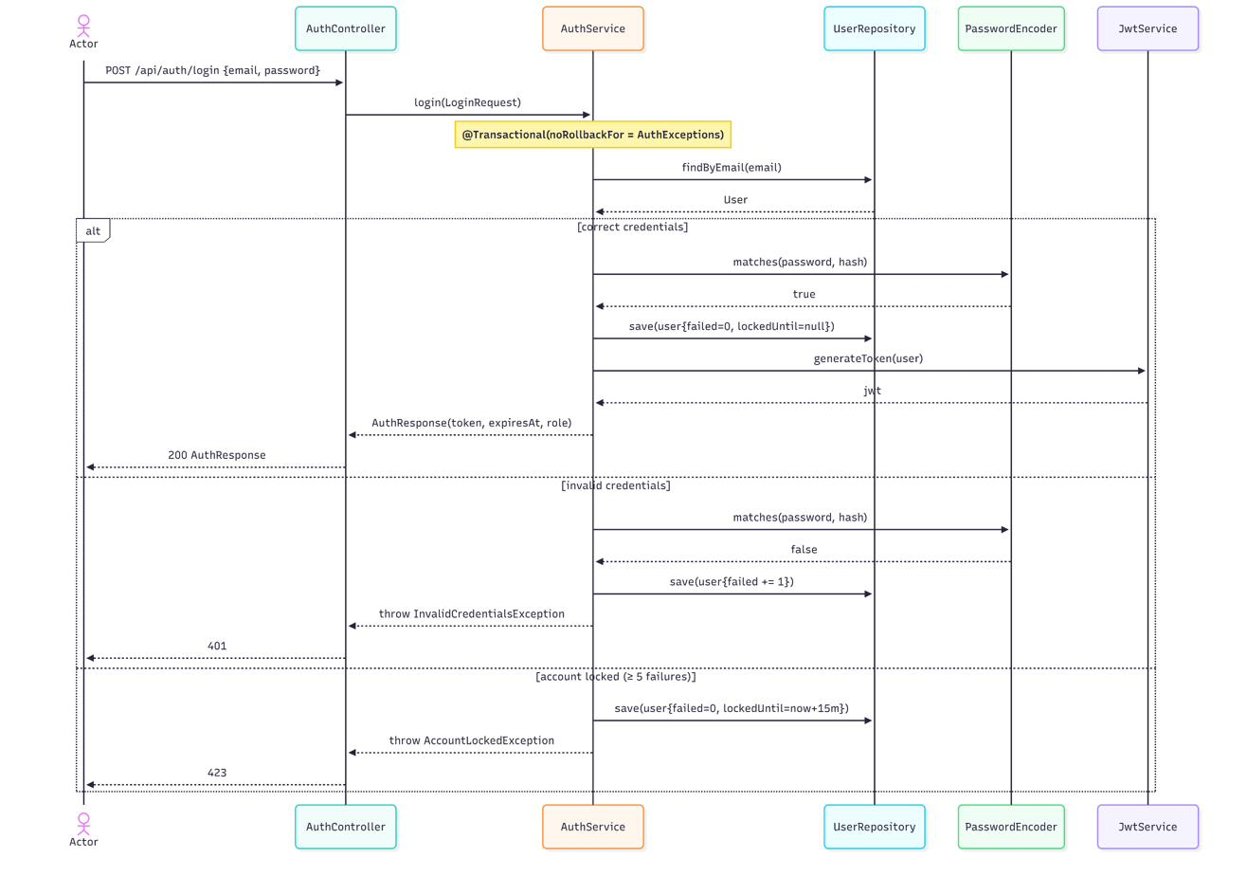
Figure 3b.2: UC2 — Log In sequence diagram

UC3 — View Notifications
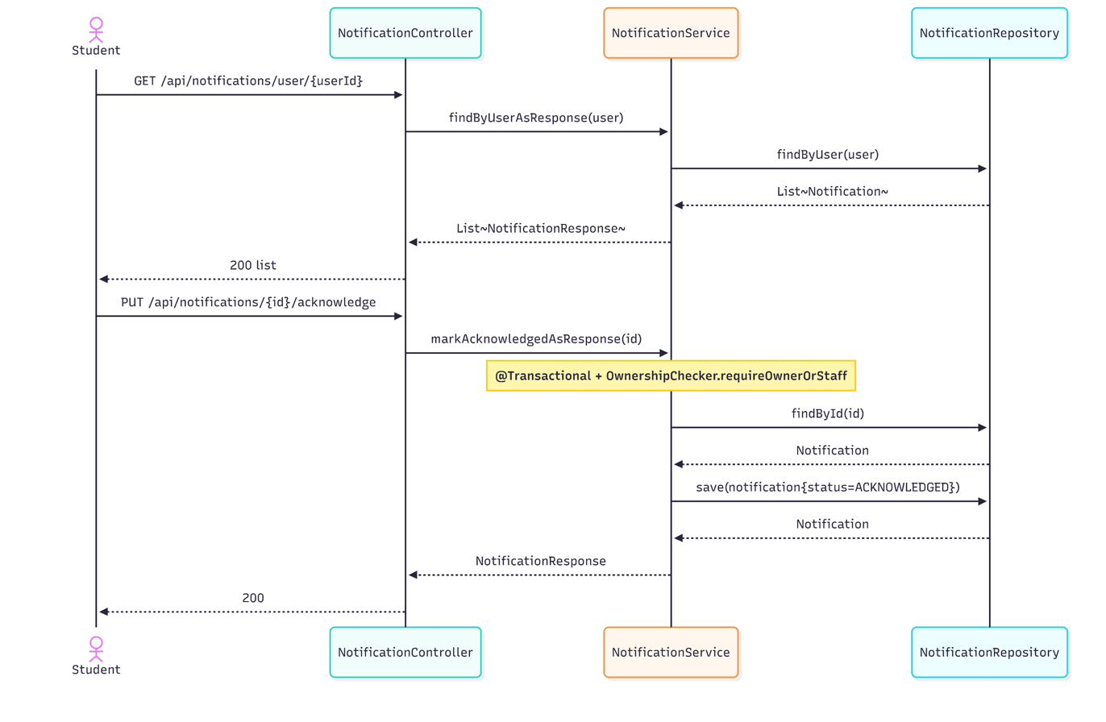
Figure 3b.3: UC3 — View Notifications sequence diagram

UC4 — Search Catalog
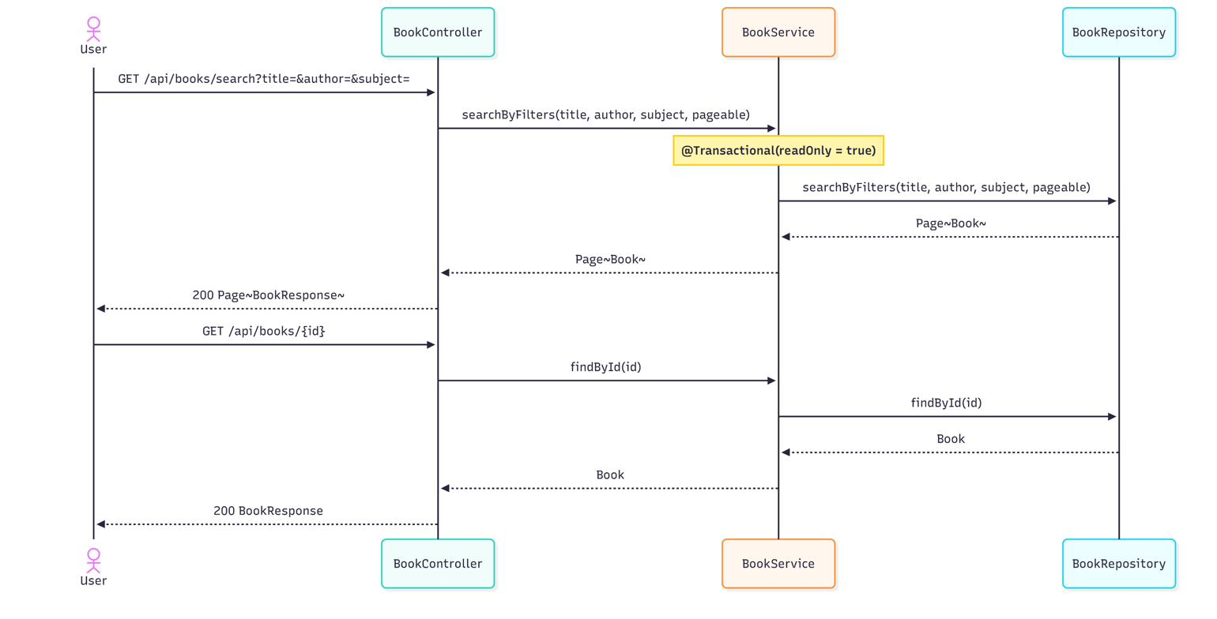
Figure 3b.4: UC4 — Search Catalog sequence diagram

UC5 — Reserve Book
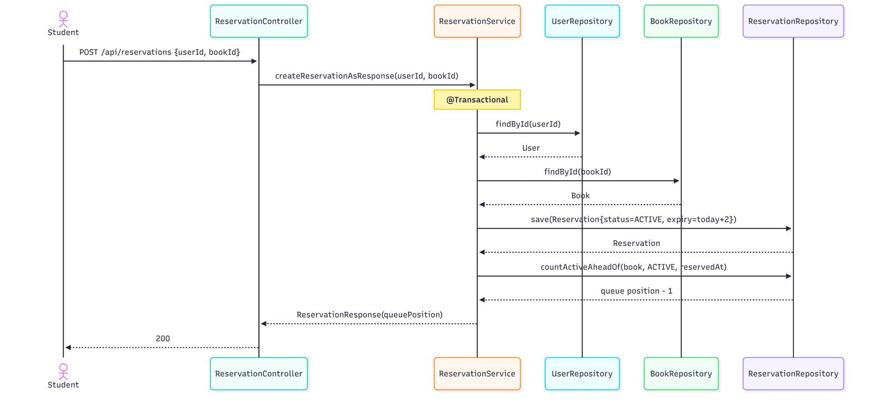
Figure 3b.5: UC5 — Reserve Book sequence diagram

UC6 — Cancel Reservation
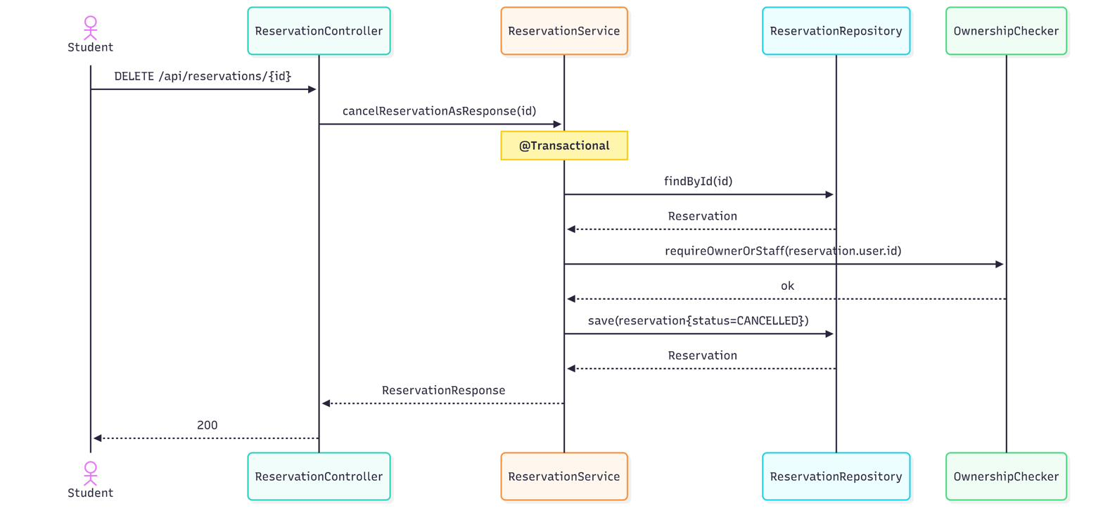
Figure 3b.6: UC6 — Cancel Reservation sequence diagram

UC7 — Borrow Book
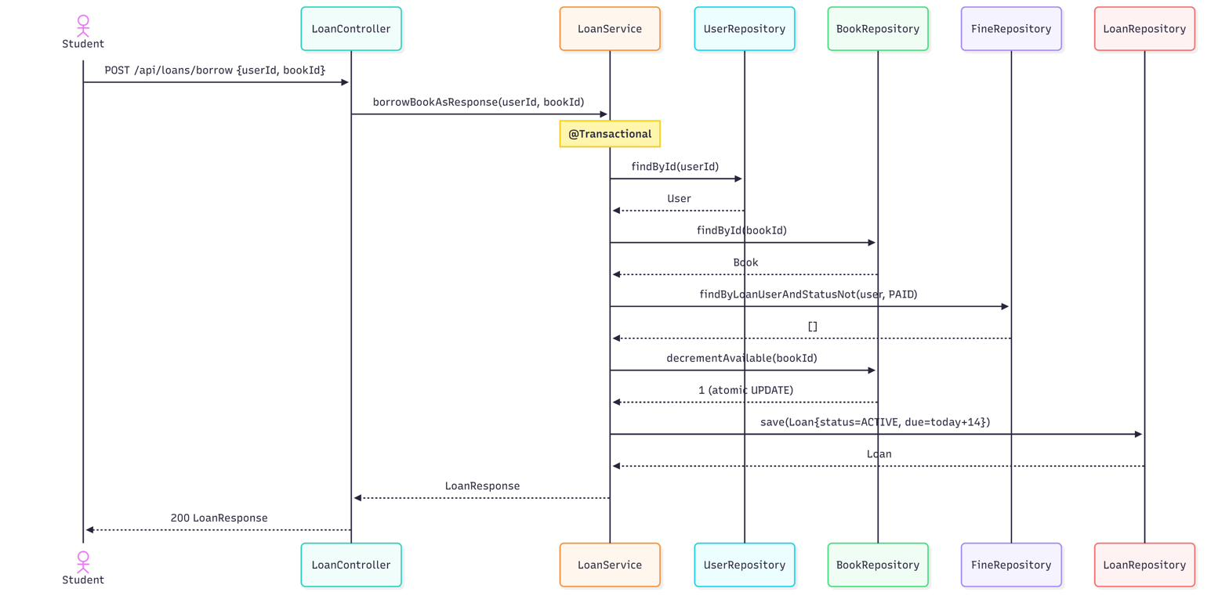
Figure 3b.7: UC7 — Borrow Book sequence diagram

UC8 — Return Book
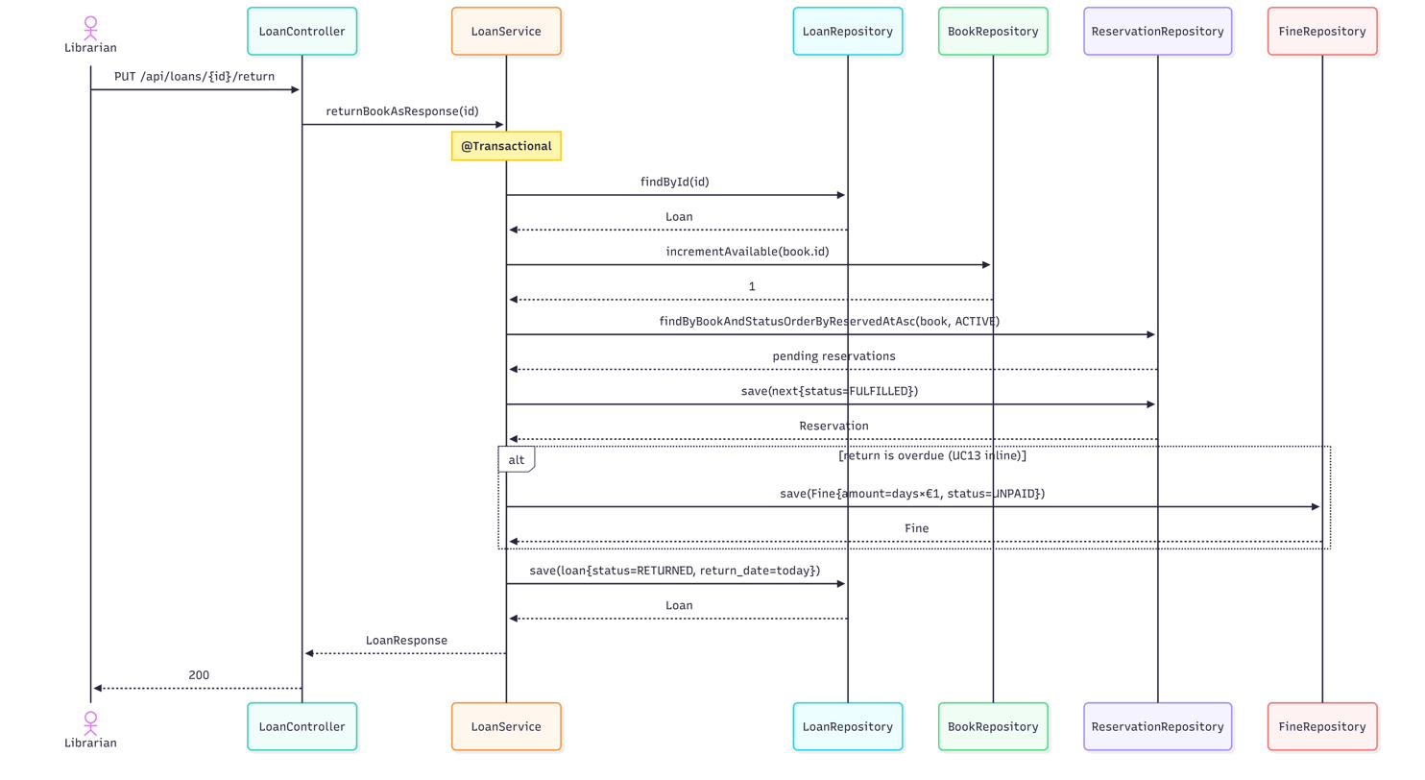
Figure 3b.8: UC8 — Return Book sequence diagram

UC9 — Renew Loan
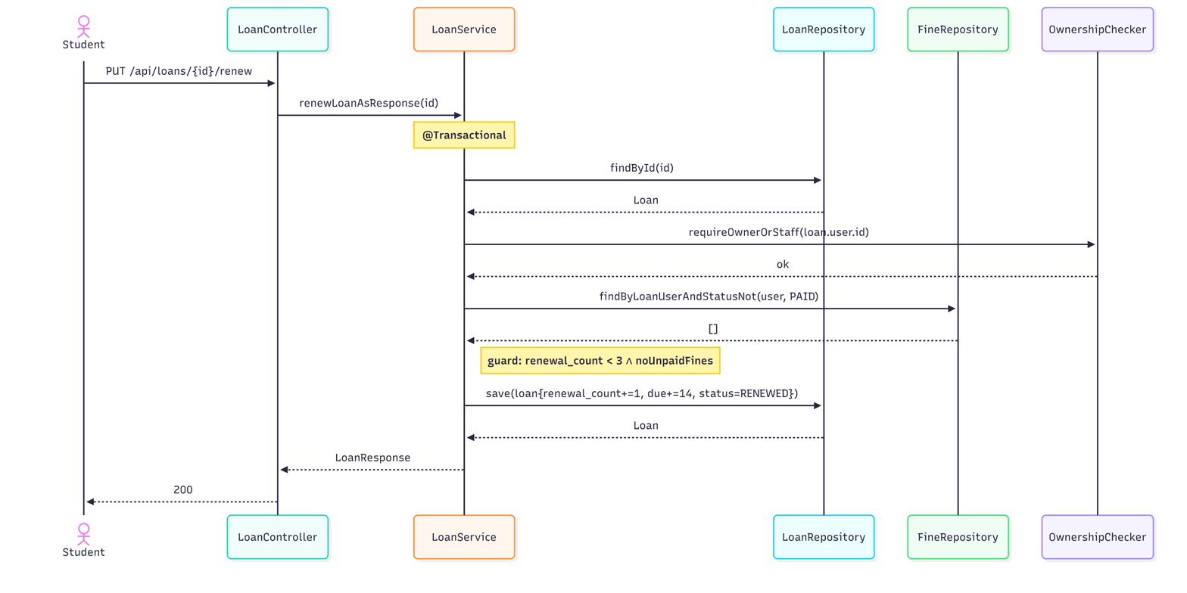
Figure 3b.9: UC9 — Renew Loan sequence diagram

UC10 — Pay Fine
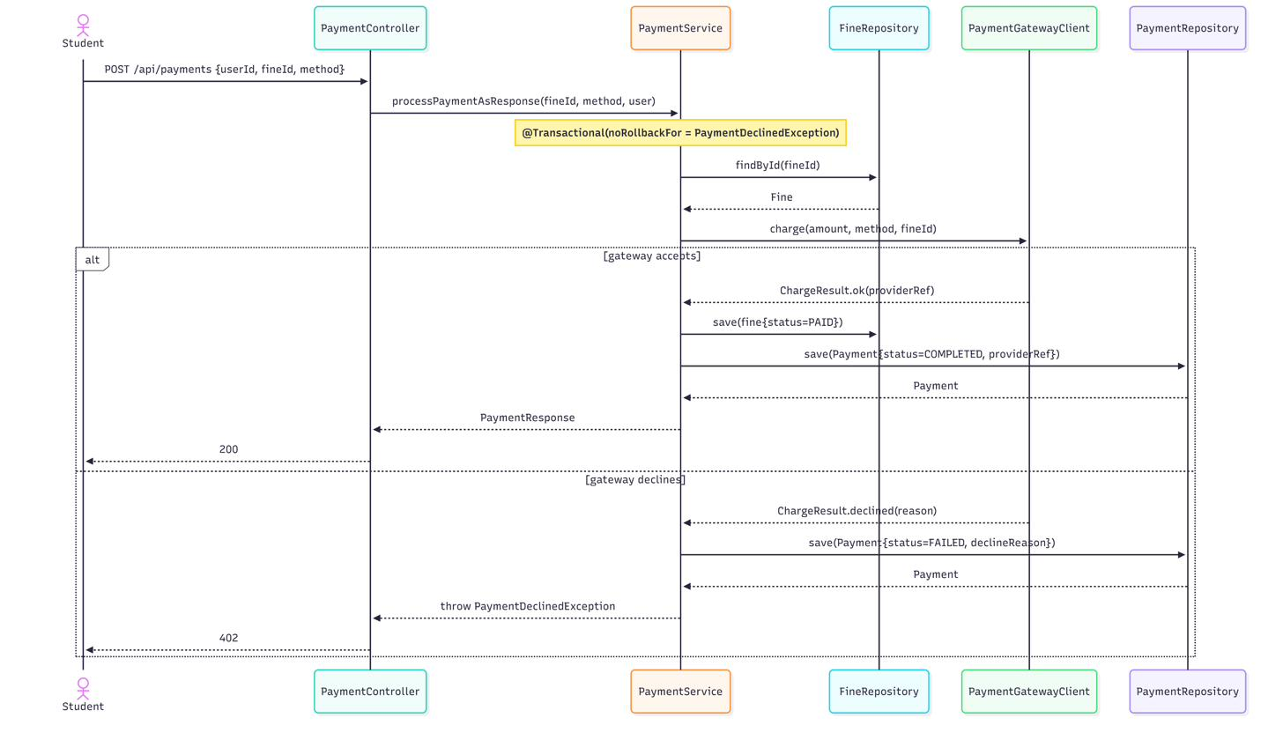
Figure 3b.10: UC10 — Pay Fine sequence diagram

UC11 — Manage Catalog
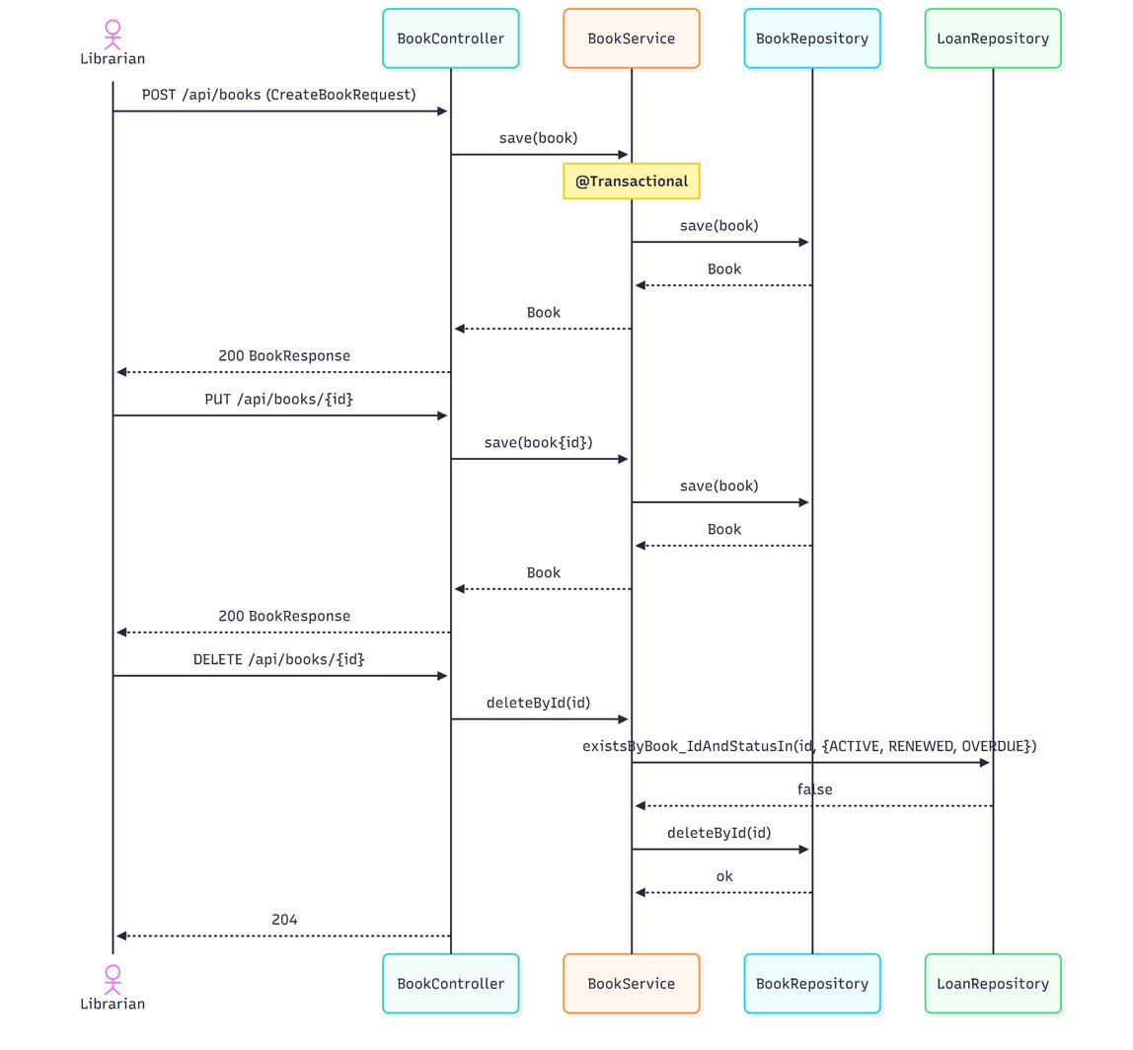
Figure 3b.11: UC11 — Manage Catalog sequence diagram

UC12 — Manage Users
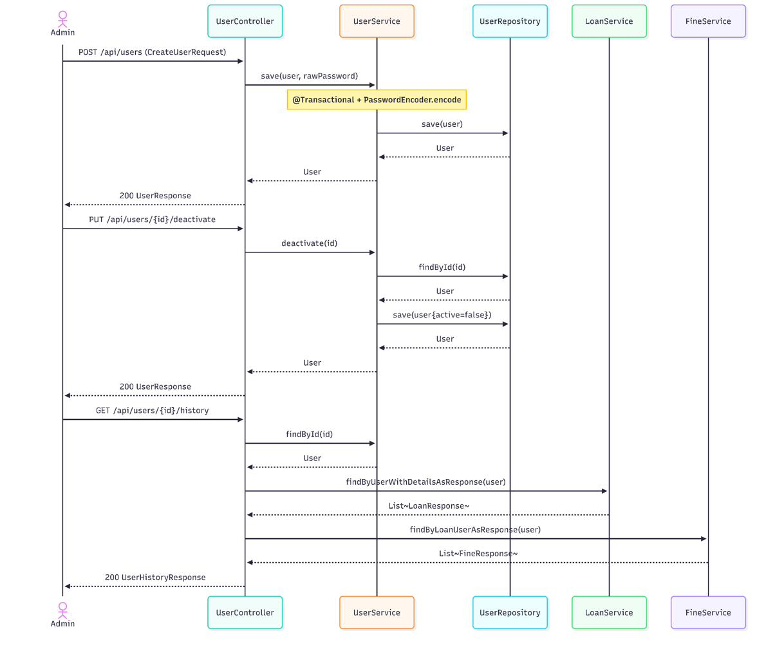
Figure 3b.12: UC12 — Manage Users sequence diagram

UC13 — Calculate Fine (system use case)
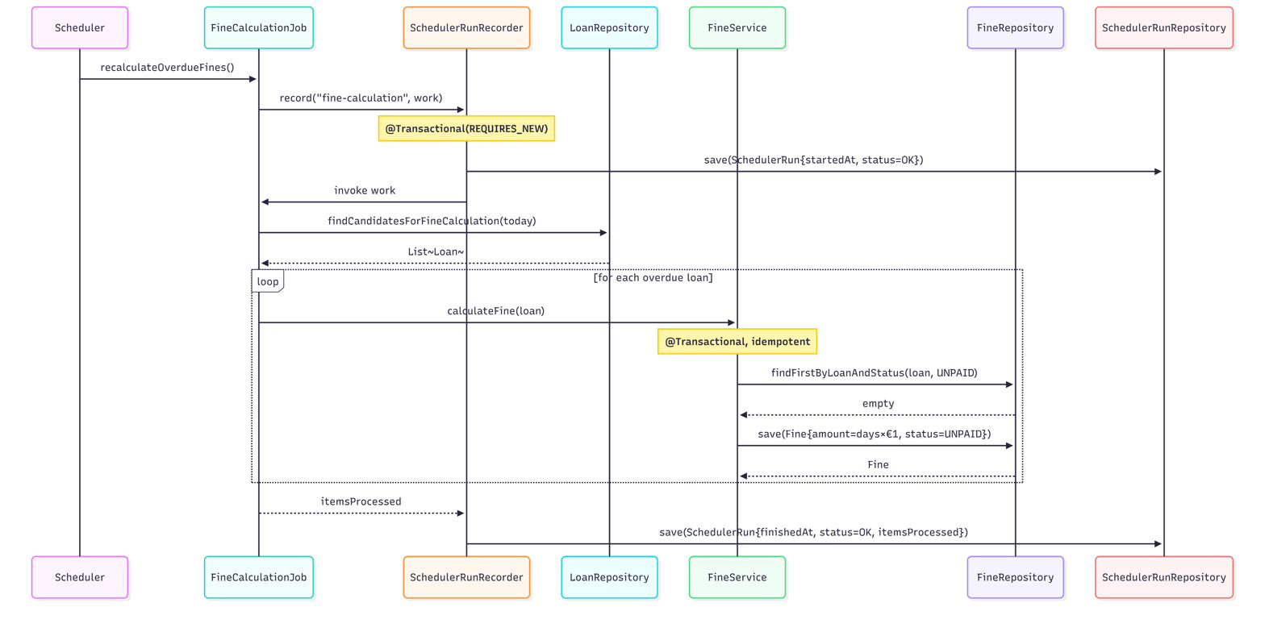
Figure 3b.13: UC13 — Calculate Fine (system use case) sequence diagram

UC14 — Send Notification (system use case)
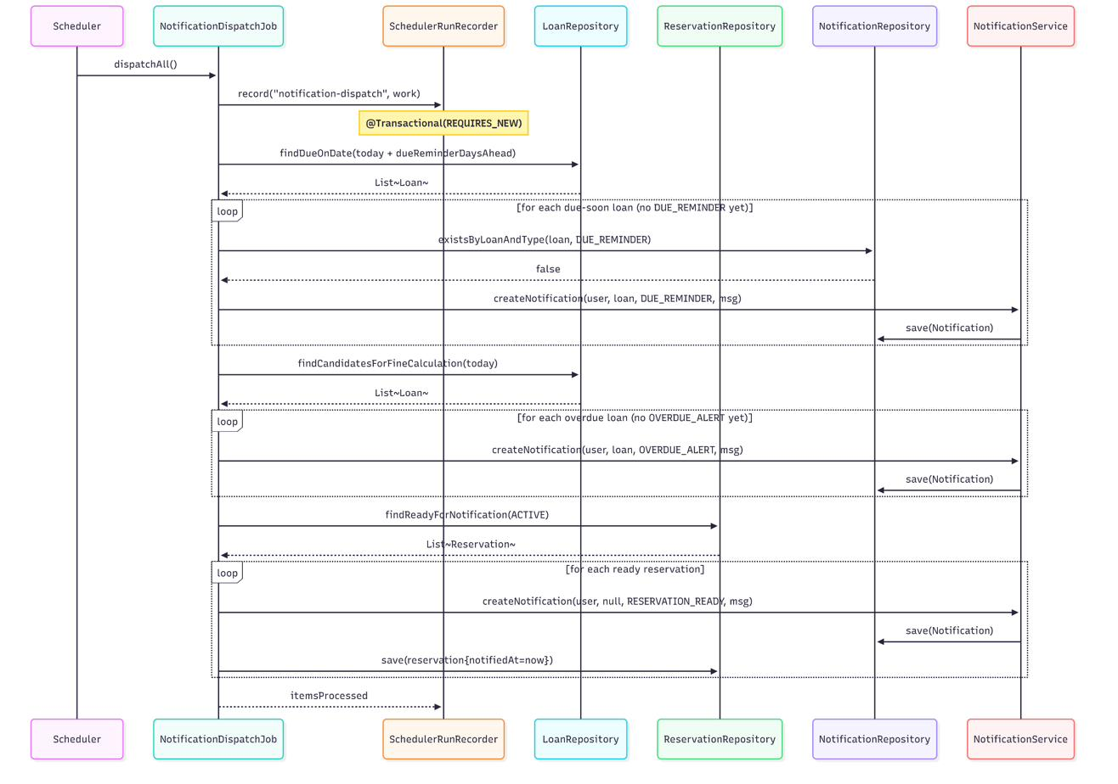
Figure 3b.14: UC14 — Send Notification (system use case) sequence diagram

3c. Loan State chart
The Loan aggregate has the richest lifecycle in the domain — it is the object that ties together UC7 (borrow), UC8 (return), UC9 (renew) and the scheduled UC13 (fine calculation), and it is the only one whose state actively gates other use cases (a RETURNED loan cannot be renewed; a RENEWED loan respects the renewal cap; an OVERDUE loan triggers fine creation on return).

States and triggers
From → To | Trigger | Code reference
[*] → ACTIVE | borrow | LoanService.borrowBook (sets status=ACTIVE, due_date=today+14, renewal_count=0)
ACTIVE → RENEWED | renew [renewal_count < 3 ∧ noUnpaidFines] | LoanService.renewLoan
RENEWED → RENEWED | renew (same guard) | LoanService.renewLoan (re-entry; up to 3 total renewals)
ACTIVE / RENEWED → OVERDUE | scheduler detects due_date < today | FineCalculationJob.recalculateOverdueFines (cron 0 0 2 * * *) — implicit via the candidate query
ACTIVE / RENEWED / OVERDUE → RETURNED | return | LoanService.returnBook (creates Fine if past due)
any → LOST (future) | not yet implemented in service code | LoanStatus.LOST is referenced only as a filter-out clause in LoanRepository.java:29,35; no setter path exists yet
RETURNED → [*], LOST → [*] | terminal | —

Diagram
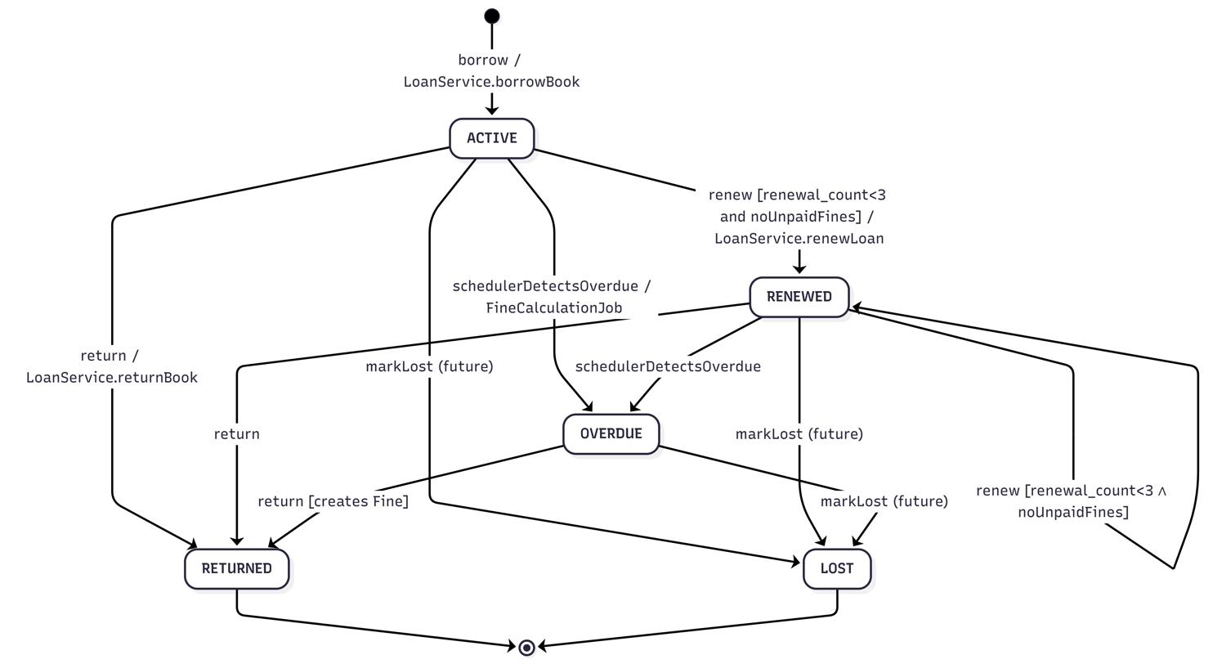
Figure 3c.1: Loan statechart

Guards
- MAX_RENEWALS = 3 — LoanService.renewLoan rejects when renewal_count >= 3.
- LOAN_PERIOD_DAYS = 14 — both initial due_date (UC7) and the renewed due_date (UC9) are extended by this constant.
- noUnpaidFines — predicate evaluated as fineRepository.findByLoanUserAndStatusNot(user, PAID).isEmpty(). Same predicate gates UC7 (borrow) and UC9 (renew).
- LOST is shown as a future state — the LoanStatus enum carries the value, the repository queries already exclude it from active sets, but no service path writes it. This is intentionally documented rather than invented for the diagram.

3d. Software Architecture

3d.1 Logical view
ULMS follows a classic layered architecture on the server side, with cross-cutting bands (security, transactions, async, scheduling) wrapping the request path. The frontend is an entirely separate Next.js application that consumes the JSON API; it has no direct database access.
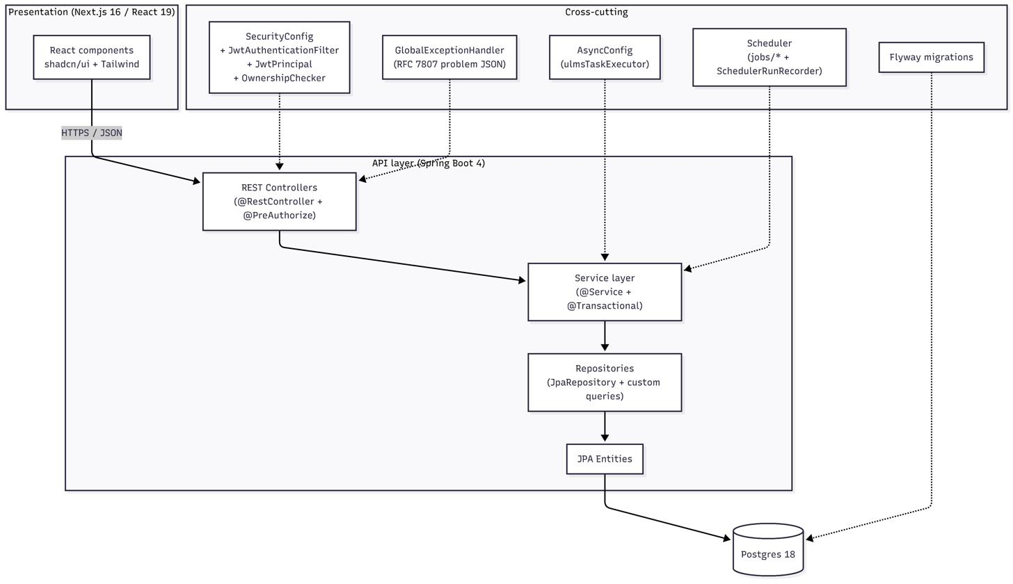
Figure 3d.1: Logical view (layered architecture)

Package map
The backend is organised under dev.tmmc.ulms:
dev.tmmc.ulms/
├── UlmsApplication (Spring Boot bootstrap)
├── config/
│ ├── SecurityConfig (filter chain, CORS, BCrypt bean)
│ ├── AsyncConfig (ulmsTaskExecutor, @EnableAsync)
│ └── OpenApiConfig (Swagger/OpenAPI groups)
├── security/
│ ├── JwtAuthenticationFilter, JwtService, JwtPrincipal
│ ├── OwnershipChecker
│ ├── RestAuthenticationEntryPoint, RestAccessDeniedHandler
├── jobs/
│ ├── FineCalculationJob (UC13)
│ ├── NotificationDispatchJob (UC14)
│ └── SchedulerRunRecorder (Template Method around scheduled work)
└── objects/
├── controllers/ (9 @RestControllers, one per aggregate)
├── services/
│ ├── (10 @Service classes)
│ ├── payment/PaymentGatewayClient, MockPaymentGatewayClient
│ └── mail/MailService, RegistrationCompletedEvent, RegistrationMailListener
├── repositories/ (9 JpaRepository interfaces)
├── entities/ (9 @Entity classes)
│ └── enums/ (9 enum types)
├── dto/
│ ├── request/ (input DTOs as Java records)
│ └── response/ (output DTOs as Java records)
├── mapper/ (static toEntity / toResponse mappers)
└── exceptions/ (typed exceptions + GlobalExceptionHandler)

Design patterns observed
The patterns below are listed only when actually present in the source — Builder, Specification, and Lombok are intentionally absent.
# | Pattern | Where it appears
1 | Repository (Spring Data) | every interface in objects/repositories/ extends JpaRepository; custom @Modifying @Query methods such as BookRepository.decrementAvailable enforce atomic counter updates at the DB level.
2 | DTO + Mapper | dto/request/*Request and dto/response/*Response are Java records; mapper/*Mapper classes hold static toEntity / toResponse methods so controllers never serialise entities directly.
3 | Strategy | services/payment/PaymentGatewayClient is the strategy interface; MockPaymentGatewayClient is the dev/test impl; PaymentService depends on the interface. A real provider can be swapped in by registering a different bean — production code in PaymentService does not change.
4 | Observer / Event (Spring ApplicationEvent) | AuthService.register publishes RegistrationCompletedEvent; RegistrationMailListener is @TransactionalEventListener(AFTER_COMMIT) + @Async("ulmsTaskExecutor"), so the email send is decoupled from the registration transaction and never blocks the HTTP response.
5 | Template Method for scheduled work | SchedulerRunRecorder.record(jobName, work) wraps every @Scheduled invocation with start time, success/failure status, error truncation, and persistence to SchedulerRun. Both FineCalculationJob and NotificationDispatchJob are clients of this template.
6 | Filter Chain | JwtAuthenticationFilter extends OncePerRequestFilter is registered by SecurityConfig.securityFilterChain before UsernamePasswordAuthenticationFilter. It is the single place where JWTs are parsed into a JwtPrincipal and pushed into the security context.

Cross-cutting concerns
- Authentication & authorisation. Stateless JWT auth (SessionCreationPolicy.STATELESS). JwtAuthenticationFilter decodes the bearer token; JwtPrincipal is exposed to SpEL, enabling @PreAuthorize("hasRole('STUDENT') and principal.userId == #request.userId()") on controllers. OwnershipChecker.requireOwnerOrStaff is used inside services for object-level checks (renew, cancel, view). RBAC roles are STUDENT, LIBRARIAN, ADMIN. Path rules: /api/auth/** is permitAll; /actuator/health|info is open; /actuator/** requires ADMIN; everything else under /api/** is authenticated.
- Transactions. @Transactional is applied at the service layer. Read paths use @Transactional(readOnly = true). AuthService.login and PaymentService.processPayment use noRollbackFor so that auth/payment failures still persist side-effects (failed-login counters, FAILED Payment rows). The scheduler recorder uses Propagation.REQUIRES_NEW so its bookkeeping survives downstream rollback.
- Validation. Controllers receive request DTOs annotated with @Valid; bean-validation failures are translated to RFC 7807 problem JSON by GlobalExceptionHandler.
- Async execution. AsyncConfig exposes a ulmsTaskExecutor (core 2, max 4, queue 50). Used by the registration mail listener; could be reused for any future fire-and-forget work without spawning a new pool.
- Scheduling. Spring @Scheduled cron jobs at 02:00 (fine-calculation) and 02:05 (notification-dispatch), Europe/Bucharest. SchedulerRunRecorder persists every invocation to scheduler_run for later observability.
- Internationalisation. ULMS ships in English. The next-intl plumbing on the frontend is dormant scaffolding — it is wired in the build but the only message catalogue is English. No backend strings are localised.
- Observability. spring-boot-starter-actuator exposes /health, /info, /metrics. Logs are structured (logback JSON), with correlation through the scheduler_run table for batch jobs. OpenAPI/Swagger is published at /swagger-ui.html via OpenApiConfig.
- Database migrations. Flyway versioned migrations under src/main/resources/db/migration/ are the single source of truth for schema; entity mappings must follow the migration, not the other way around.
- Security defaults. Passwords are BCrypt (PasswordEncoder bean in SecurityConfig); JWT secret and lifetime are externalised via application.yml (ulms.security.jwt.*); CORS allowed-origin is a single configurable value.

3d.2 Physical view
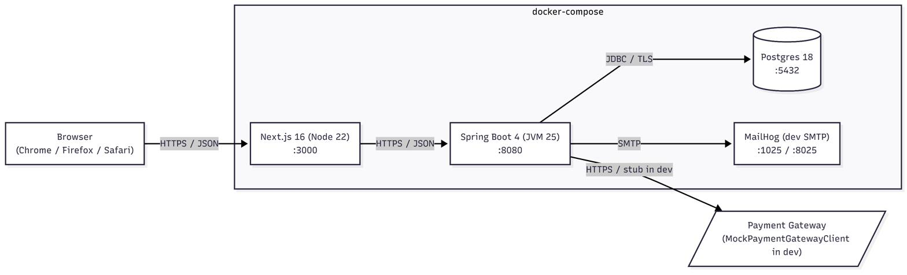
Figure 3d.2: Physical view (deployment diagram)
The runtime layout intentionally treats the frontend and the backend as separate processes so that they can be scaled, deployed, and operated independently. Postgres runs inside the docker-compose box during development; in production it is expected to be a managed instance (RDS / Cloud SQL / equivalent), with the same connection string injected through environment variables.

Tech stack rationale
Concern | Choice | Rationale
JVM | Java 25 | Latest LTS-track with virtual threads available where useful.
Backend framework | Spring Boot 4.0.3 | Mature ecosystem, first-class JPA / Security / Validation / Actuator.
Persistence | Spring Data JPA + Hibernate 6 | Repository abstraction matches the layered design; DDL is owned by Flyway, not Hibernate.
Schema migrations | Flyway | Versioned, repeatable, runs on app startup.
Auth | Spring Security + JWT + BCrypt | Stateless, role-based, no server-side session store.
Validation | Jakarta Bean Validation | Declarative on DTOs, integrates with @Valid and MethodArgumentNotValidException.
API docs | springdoc-openapi | Auto-generated OpenAPI 3 spec + Swagger UI from controller annotations.
Database | Postgres 18 | ACID, mature, JSONB available for future flexible columns.
Frontend framework | Next.js 16 + React 19 | App Router for server components where useful; same team can iterate on UI without touching backend.
UI primitives | shadcn/ui + Tailwind CSS | Accessible primitives; design system is extensible without an external component library lock-in.
Frontend testing | Playwright + axe-core | Cross-browser E2E (Chromium, Firefox, WebKit) plus accessibility lint in jsdom unit tests.
Backend testing | JUnit 5 + Mockito + Spring @DataJpaTest / @WebMvcTest | Standard slice + integration testing pyramid.

Configuration management
- src/ulms/src/main/resources/application.yml declares profiles (dev, test, prod); environment-specific overrides live in application-{profile}.yml.
- Secrets (JWT secret, DB password, payment-gateway token) are read via @Value("${ulms.…}") from environment variables; nothing secret is committed.
- The frontend reads its API base URL from NEXT_PUBLIC_API_URL and never embeds it at build time except for previews.
- CORS allowed origin is a single configurable value (ulms.security.cors.allowed-origin) so dev / staging / prod can each pin to their own domain.

